**Setting up Java Derby Database using NetBeans**

**Step 1:** Download the file **dbDerby.zip** in the Lab folder on Moodle page: <https://moodlecurrent.gre.ac.uk/mod/folder/view.php?id=2480440> to the local disk in folder:

C:\Users\yourOwnUserID(such as: AB123d)\Downloads

And then UNCOMPRESS the file **dbDerby.zip** in the same folder.

**Step 2:** Open Netbeans IDE and click “**Services**” page:

Then right**-click** the Java DB Database node and choose **Properties** to open the Java DB Settings dialog box.

For **Java DB installation**, you need to specify the install directory of Java (Derby) DB:

C:\Users\ yourOwnUserID(such as: AB123d)\Downloads\dbDerby\db-derby-10.14.2.0-bin

For **Database Location (**the location of the database to be created**),** you can use a NetBeans project folder. Click OK

C:\Users\ yourOwnUserID(such as: AB123d)\Downloads

**Change to your own userID**

**Change to your own userID**

**Step 3:** In the Services window, right-click the Java DB node and choose Start Server. Note the following output in the Output window, indicating that the server has started:

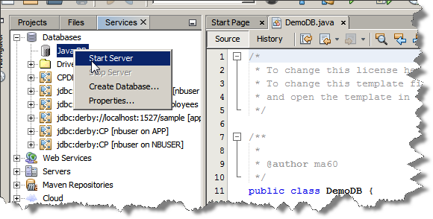



Right-click the Java DB node and choose Create Database to open the Create Java DB Database dialog.

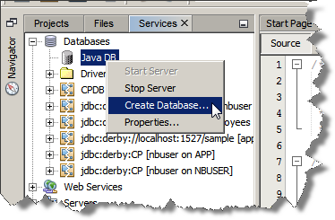

Type the name of database, *UserDB*, in Database Name.

Type *use* for the User Name and your Password. Click OK.

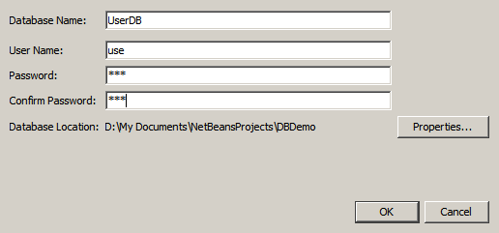

After you create the database, if you expand the Databases node in the Services window you can see that the IDE created a database connection and that the database was added to the list under the Java DB node.

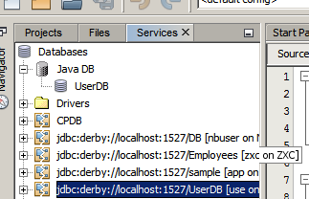

So far, you have successfully started the the database server and created a database instance named UserDB in the IDE. In the Services window of the IDE you can perform the following common tasks on database structures.

* creating, deleting, modifying tables
* populating tables with data
* viewing tabular data
* executing SQL statements and queries

In order to begin working with the UserDB database, you need to create a connection to it. To connect to the UserDB database perform the following steps.

1. Expand the Databases node in the Services window and locate the new database and the database connection nodes.

The database connection node( ) is displayed under the Databases node. The name of the database is displayed under the Java DB node.

2. **Right-click the UserDB database connection node**

**(jdbc:derby://localhost:1527/ UserDB [use on USE]) and choose Connect.**

The connection node icon appears whole ( connection node icon), signifying that the connection was successful.

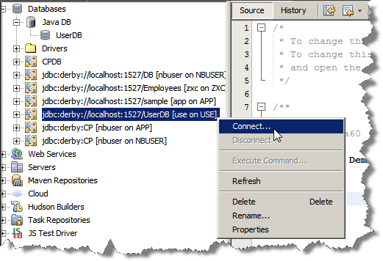

The UserDB database that you just created is currently empty. It does not yet contain any tables or data. In NetBeans IDE you can add a database table by either using the Create Table dialog, or by inputting an SQL statement and running it directly from the SQL Editor. You can explore both methods.

**Using the Create Table Dialog**

1. Expand the UserDB connection node and note that there are several schema subnodes. Right-click the UserDB node and choose Set as Default Schema.

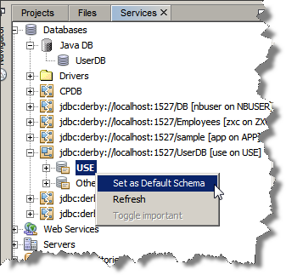

1. Expand the UserDB node and note that there are three subfolders: Tables, Views and Procedures. Right-click the Tables node and choose Create Table to open the Create Table dialog box.

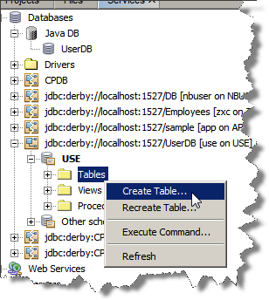

1. In the Table Name text field, type users.
2. Click Add Column. The Add Column dialog box appears:

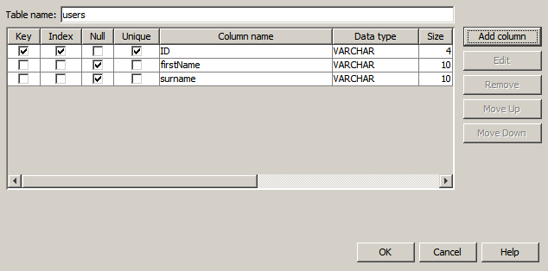

Now that you have created one or more tables in the contact database, you can start populating it with data. There are several ways that you can add records to your table.

* [Write an SQL statement](https://netbeans.org/kb/docs/ide/java-db.html#sqlstatement) in the SQL Editor that supplies a value for every field present in the table schema.
* [Use the SQL Editor](https://netbeans.org/kb/docs/ide/java-db.html#usesqleditor) to add records to the table.
* [Use an external SQL script](https://netbeans.org/kb/docs/ide/java-db.html#using) to import records to the table.

**Running an SQL Statement**

Expand the Tables under the Contact DB node in the Services window, right-click the FRIENDS table and choose Execute Command to open the SQL Editor window.

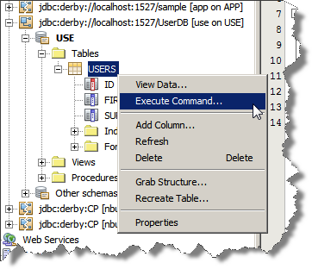

In the SQL Editor, enter the following statement.

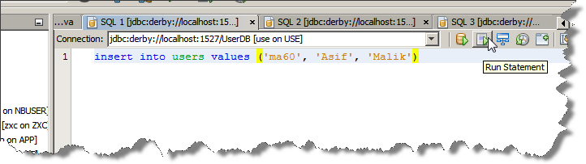

Once you have added data to your table, click on the Projects tab. Now add the Derby drivers to your project. Right click on the Libraries folder and select Add Library.

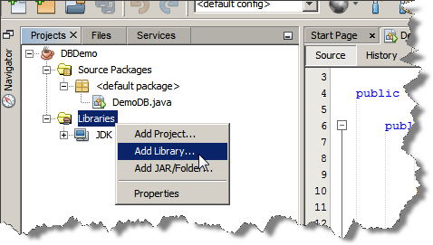

From the list select Java DB Driver

